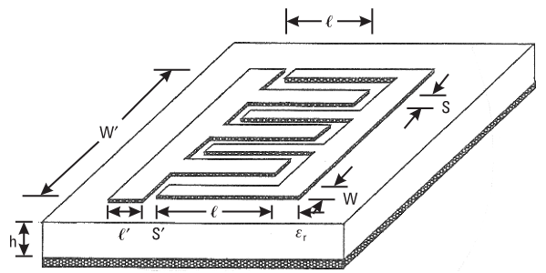
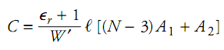
- capacitance per unit length along W’:
- A₁ , A₂ – capacitance per unit length of the fingers
- N- Number of fingers.
- l- Shown in the picture- expressed in microns.

- For infinite number substrate thickness (or no ground plane) –
A₁= 4.409*10⁻⁶ pF/µm.
A₂= 9.92*10⁻⁶ pF/µm.
- The total capacitance of an interdigital structure of length l is expressed as:

- For a finite substrate:
$$A_{1}=4.409*\tanh\left[0.55*{\left(\frac{h}{w}\right)}^{0.45}\right]*{10}^{-6} [\frac{pF}{μm}]$$
$$A_{2}=9.92*\tanh\left[0.52*{\left(\frac{h}{W}\right)}^{0.5}\right]*{10}^{-6} \left[\frac{pF}{μm}\right]$$
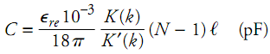
- Another general expression for the total series capacitance of an interdigital capacitor can also be written as:

  - l is in micron
  - N – number of fingers
  - $ϵ_{re}$- effective dielectric constant of the microstrip line of width W
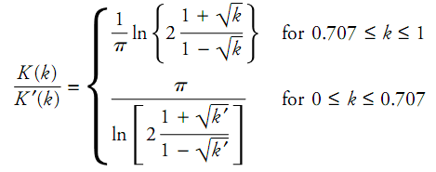
where:
and:

